# ROI-Editor

Choose ROIs->ROI Editor

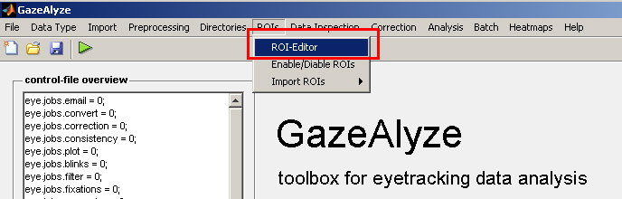

A huge window will pop up, but it is easy to specify a ROI. See below the picture to see a step by step guidance.

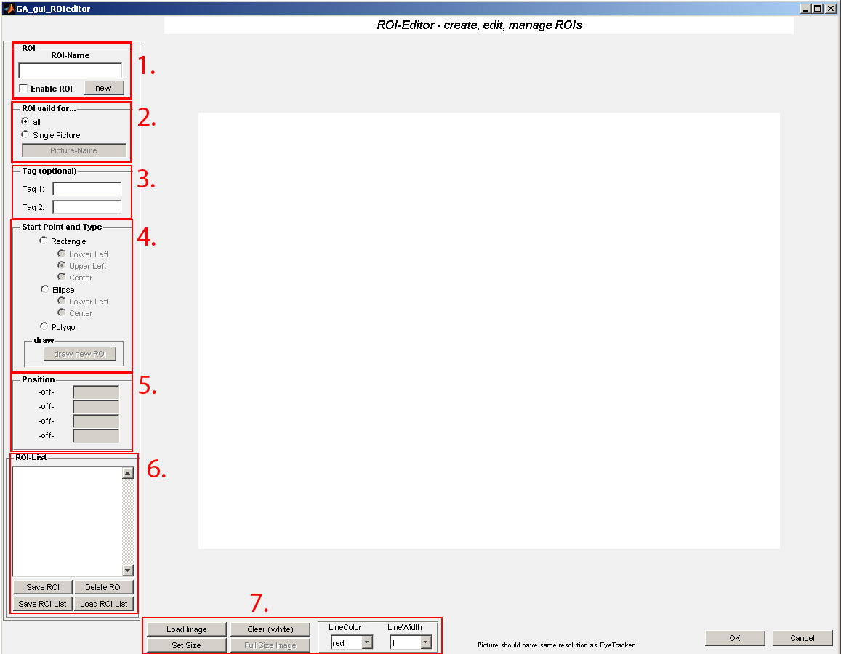

1. Enter a ROI-Name and enable the ROI.
2. Select if the ROI is valid for all pictures or only a single picture. If it is valid for one picture, type a picturename.
3. Tags to descripe the ROI, not needed for program right now. Just for you if you would like to give notes.
4. Select what kind of ROI you would like to use… a rectangle, an eclipse or a polygon. Now you can select draw new ROI to directly draw it on the screen OR give a position (see point 5)
5. Shows the ROI position x-y-width-height. You can enter values here manually. Will be disabled if your ROI-type is polygon.
6. Now click Save ROI and your ROI will be saved and show up in the ROI-List. You can select ROIs here to modify or delete them. It is also possible to export or import a ROI-list.
7. Some Options to modify the Editor, you can load a background picture, set the size of the wallpaper (default 800x600), or play with the linecolor, linewidth if you can’t see it right on the picture.

Enable/Disable ROIs is optional

Import ROIs is optional